Guidance Technique Matrix

Guidance Technique | Description | Why it Works | Example
Lighting | Bright areas naturally draw player attention | Human vision is drawn towards contrast and illumination | Portal (2002, Valve)
Landmarks | Large recognisable objects that are easily identifiable and draw the player towards them | Players build mental maps using landmarks | Disney Weenies (A term used in the Disney Theme parks – A distinguishable landmark that will help visitors know where they are)  Positive & Negative space  Death Stranding (Vast Open World, landmarks usually mean there is a terminal near by)
Audio | Sounds attract attention or imply direction | Players investigate sound sources | The last of us  Friday 13th (Audio Prompt is played when the killer is near the survivors)
Colour Contrast | Bright colours distinguish interactable routes | Creates visual hierarchy | Mirrors Edge  Resident Evil Series  Final Fantasy Remake

Game Analysis
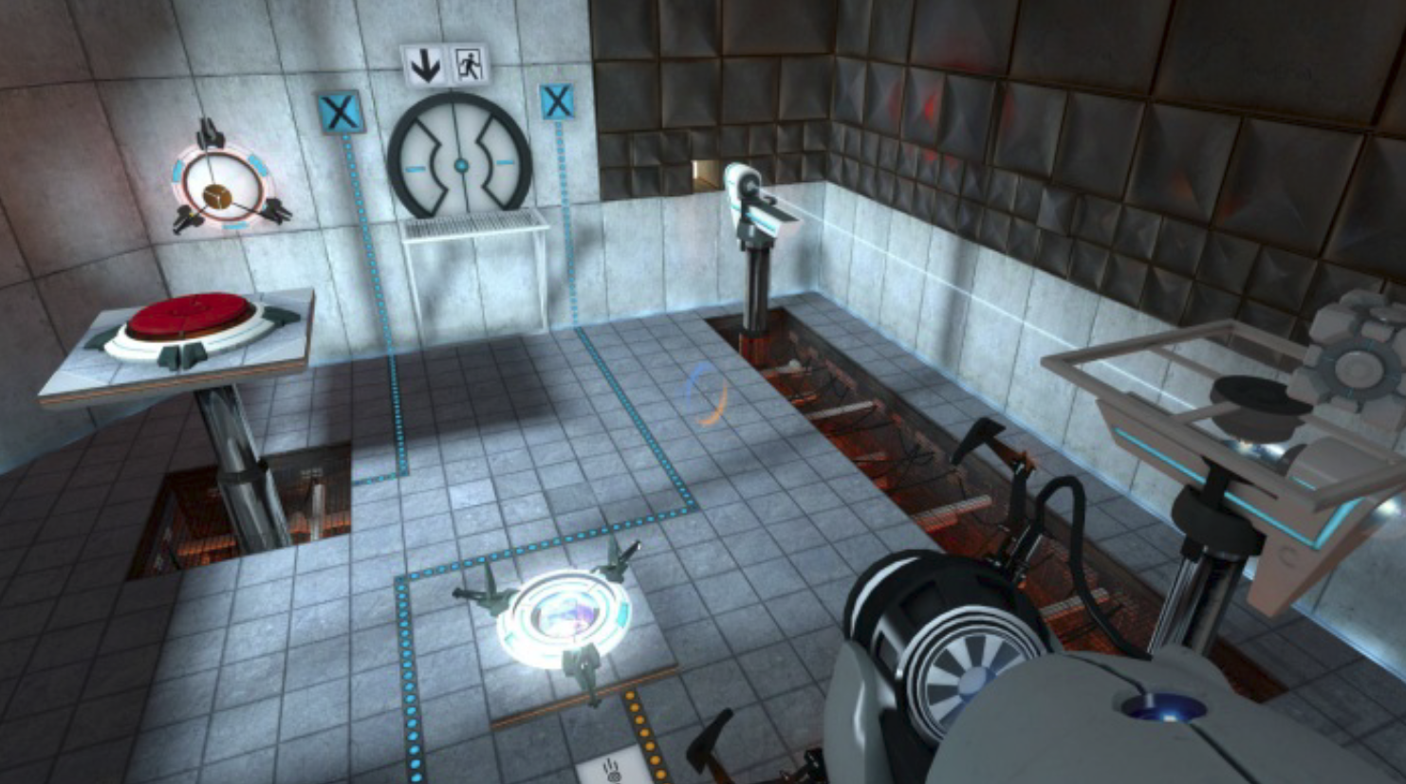
Portal (Valve)
Technique | Example
Lighting | Exit doors and important objects are brightly illuminated
Framing | Rooms naturally frame the next objective
Colour Contrast | White Surfaces indicate that portals can be placed on
Architecture | Chambers funnel the player towards the puzzle solutions

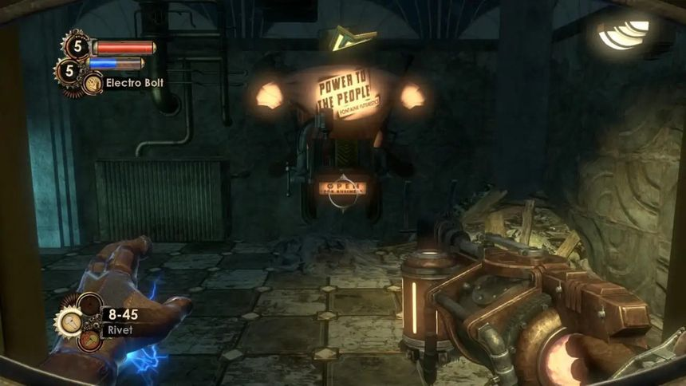
BioShock
Technique | Example
Landmarks | The lighthouse acts as a memorable navigation landmark
Lighting | Warm lighting highlights important paths
Framing | Corridors reveal important spaces gradually
Audio | Enemy sounds draw attention
Environmental Storytelling | Blood trails, destroyed rooms and props imply where events occurred
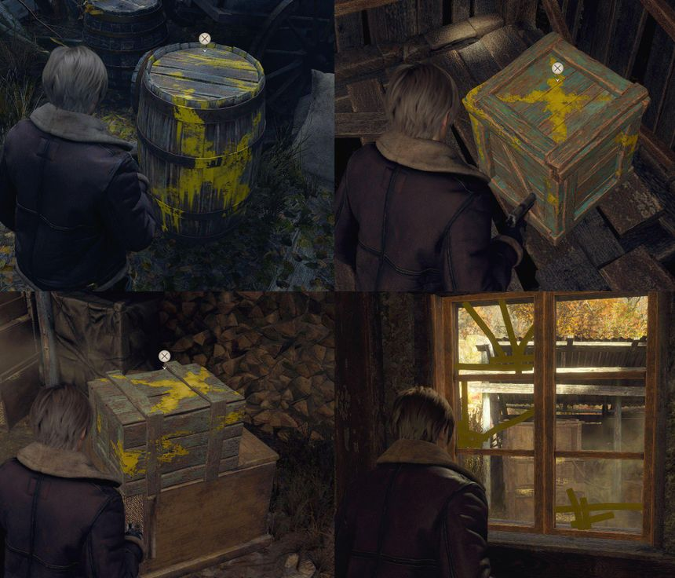
Resident Evil 4 Remake
Technique | Example
Yellow Paint | Highlights climbable objects and interactable
Lighting | Warm lighting attracts players towards objectives (torches, lamps)
Environmental Storytelling | Broken barricades indicate intended routes


Mirrors Edge
Technique | Example
Colour Contrast | Runner Vision highlights traversal routes using red
Architecture | Rooftops naturally create flow
Landmarks | Large buildings orient navigation

Literature notes
The best/most relevant GDC talk I have watched has been Level Design Workshop: Blockmesh and Lighting Tips – This talk covered player guidance, how to
Affordances (ladders, wal hang things)
Valves (drop down cant get back up)

Other Videos that have supported my research:
Using Level Design Tools Expressively
Building New York in Marvel's Spider-Man: It's Still Just Level Design
Fallout 4's Modular Level Design
Video Game Hand Holding and the Yellow Paint Discourse
What’s With Yellow Paint In Games?
Half-Life 2's Invisible Tutorial

Prototype Plan
- Create a Reusable scene
- Find a free and open licence asset pack
- Come up with a small prototype premise that is universal to all guidance techniques
- Create the level in Unreal
- Duplicate level for each guidance technique/Create a shortcut in one level that can toggle different techniques on and off (this approach is less likely)

- Create Guidance Technique One

References (if that’s the right word)
